INFARED THERMAL SCANNING OF ELECTRICAL SYSTEMS
Why is this an Issue
Electrical services represent one of the primary causes of fires in industrial and commercial facilities

What can be done to upgrade to Best Practice Standards

We recommend consideration of a thermographic scan of the main electrical services to be conducted on a [6 monthly] basis. These scans provide an infrared image of the electrical switchboard which allows any “hot spots” to be identified.

“Hot spots” may occur due to overloaded circuits or something as simple as a loose connection.

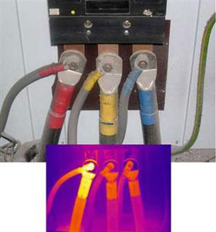
“Hot spots” are generally indicators of potential fire sources and therefore, early identification will allow rectification before a fire occurs.

The Australian Professional Thermography Association has a web site where you can search for members by location

http://www.auspta.asn.au

