COMMERCIAL COOKING EQUIPMENT

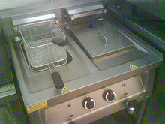

Why is this an Issue
The three primary types of equipment involved in restaurant cooking fires are deep-fat fryers, cooking ranges and cooking grills.

Grease vapours given off during the cooking of nearly all types of food will accumulate on the hood, in the duct and fan of the exhaust system.

This grease residue is combustible at approximately 370 degrees C and the heat within a cooking appliance flare-up can easily reach 1100 degrees C.

So, if the flames linger long enough in the hood or duct, the internal grease build-up will ignite, with the potential to develop into an uncontrolled fire that can be quickly “sucked” through the entire length of the duct.

What can be done to upgrade to Best Practice Standards

All ranges should be equipped with cooking thermostats with maximum temperature set 205 degrees C.;

Ranges should be fitted with a high temperature limit control set at 230 degrees C.;

Ranges should be fitted with lids or shutters to allow for safe closure in the event of a fire;

A remote shutdown facility should be available to shut down fuel, power and extraction system and the device should be clearly labelled;

The ranges should be serviced, at least annually, by a qualified person in accordance to manufacturer’s instructions;

Filters should be cleaned monthly at a minimum,;

Extraction ducts should be cleaned regularly in accordance to use or 6 monthly as a minimum;

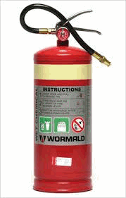
Wet Chemical Fire Extinguishers are the most suitable type of extinguisher for fat Frying fires.

Fire blankets are installed and all fire equipment and are being maintained under contract

The ultimate Best Practice is the installation of a kitchen fire suppression system which is designed to combat the dangerous fires that occur in cooking appliances and ductwork in commercial kitchens.

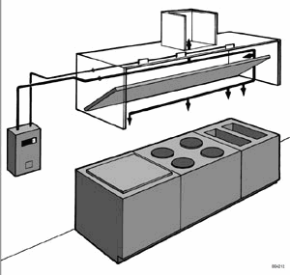
The system can be installed directly into the hood and ductwork of your cooking appliances - completely out of sight where it will not interfere with the appearance or operation of your kitchen.

KITCHEN MAINTENANCE LOG BOOK

Enter dates cleaned or maintained
Filters Cleaned  Minimum Monthly | Ducts Cleaned  Six monthly (min.) | Equipment Maintenance  Annual

